- Hero section:
Top badge:
Built for Façade & Construction Teams
Hero section heading:
Intelligent Systems for the Façade & Construction Industry
Paragraph:
We design AI-powered platforms, automation, and custom software that streamline construction workflows—from drawings and estimation to site operations and project delivery.
CTA
Book a Discovery Call
Explore Solutions
Hero section small stats cards:
-Workflow-First Approach
-Custom-Built Systems
-Built for Façade Teams
2- Who We help (Already done where you have shown trade cards).
Top badge:
Instead of “Across the envelope”
Use “Who We Build For”
Heading: “Built for the Specialists Behind Modern Buildings.”
Paragraph: From façade engineering to wider construction operations, we build intelligent systems around the way these teams work.

3- The problems We Solve (Design would be same as Why companies choose AI)
Top Badge:
“Where We Create Impact”
Heading: Construction moves fast (dark green colour). Your workflows should too (Olive color).
Paragraph:
Every project depends on hundreds of repetitive decisions—from reviewing drawings and preparing quotations to tracking fabrication and documenting site progress. We build intelligent systems that remove friction from these everyday workflows.
Right side cards:
- Manual Estimation
Still reviewing drawings manually and building quotations in spreadsheets?
- Drawing Revisions
Tracking revisions across multiple drawing versions wastes engineering hours.
- Site Reporting
Disconnected inspections slow communication between site and office.
- Fabrication Tracking
Production, installation and documentation often live in separate systems.
Use Respective icons on Cards.
After last card. One sentence fades in.
“Every workflow is different. That's why every solution we build starts with understanding how your team works.” Then next section (Service section) is shown.
4-Our Services
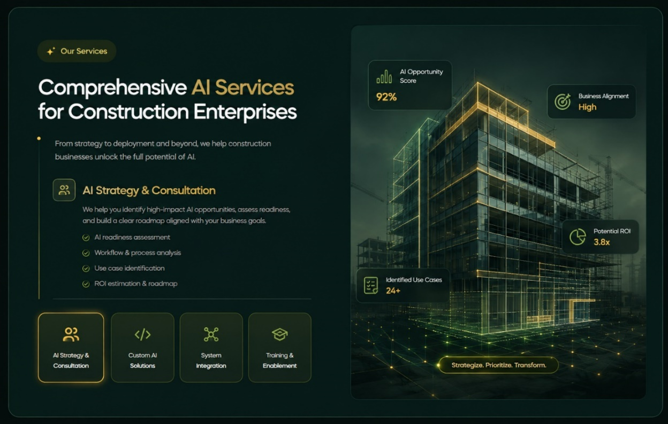
Badge:
HOW WE HELP
Heading:
From Workflow Challenges to Working Solutions.
Paragraph:
Every construction business operates differently. We combine software engineering, AI, and deep workflow understanding to build systems.
Services:
1- Workflow Analysis & Consulting
Description:
We study how your teams work today, identify where time and accuracy are being lost, and define the opportunities where custom software or AI can create real.
Points:
- Workflow & process assessment
- Operational bottleneck analysis
- Automation opportunity mapping
- Solution roadmap & recommendations
2-Custom AI Development
Description:
Every solution is built specifically for your business, not adapted from a generic product.
Points:
- Drawing & document intelligence
- Workflow automation
- AI assistants & copilots
- Computer vision & data extraction
3-Integration Services
New systems should work with the tools you already rely on. We integrate systems with your existing systems to make a digital environment.
Points:
- API integrations
- BIM & drawing workflows
- ERP / CRM connectivity
- Data synchronization
4-Training & Implementation
Heading:
Training & Implementation
Description
We support your team through onboarding, training, rollout, and continuous improvements to ensure every solution becomes part of your daily operations.
Points:
- Team onboarding
- Implementation planning
- User training
- Ongoing support

- Our featured Solutions Section
Section badge:
“FEATURED SOLUTIONS”
Heading:
Systems Built for Real Construction Workflows.
Paragraph:
Explore a selection of client systems, internal products, and innovation projects designed to streamline operations, reduce manual work, and improve the way construction teams deliver projects.
Each Product card should have:
- [ Category Badge]
- Solution Mockup
- Solution name
- One line description
- Button (shows only on hover)
Note:
For this change you must increase card height and increase card width as well and show only 2 solutions in a row. Total show 4 solutions in featured section.
Follow this structure for card: but keep design, colors same as you made previously.
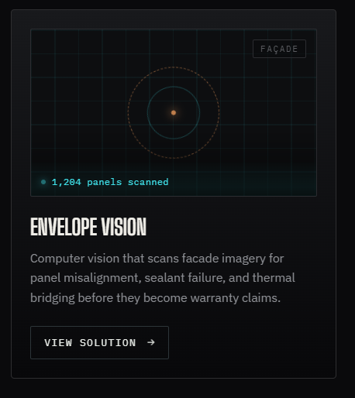

For now, Do till this:
--------------------------------------------------------------------------------------------------------------

6- Our AI Transformation Framework (keep it same)
Make this section looks like Storyline
Discover -> Consult ->Design ->Develop -> Integrate -> Train -> Optimize
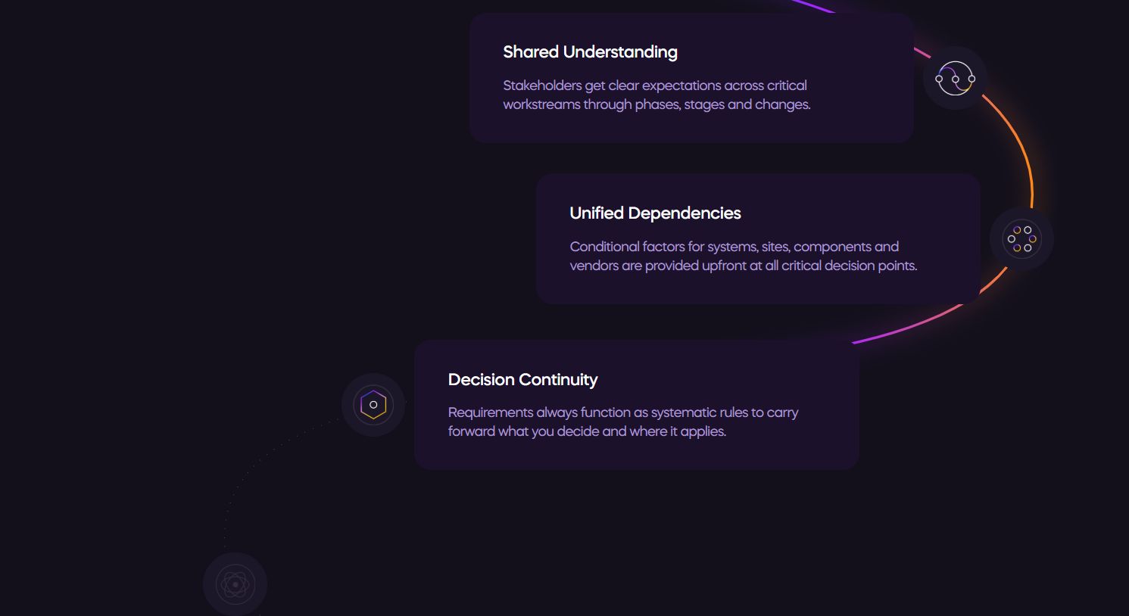
7-Featured Case Study
Make section Like this. But don’t make it too much over. What to add:
1- Top badge
2-Heading
3-Paragraph
4- Center product mockup, first only show laptop mockup and after 3seconds show mobile mockup.
5-Feature cards around the around the product mockup.
Note: Use the below image just for reference of structure. Use the same content as image but don’t make it overly loaded. Use my system colors instead of the colors in image. Don’t add the features that are shown below mockup.
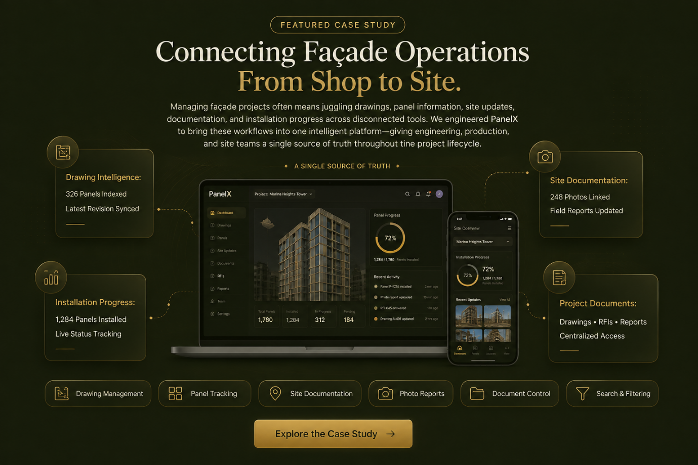

8- Trusted By section (You already done):
9- Why work with us
Badge: What Makes Us Different
Heading: Adjust the Heading in 1 line.
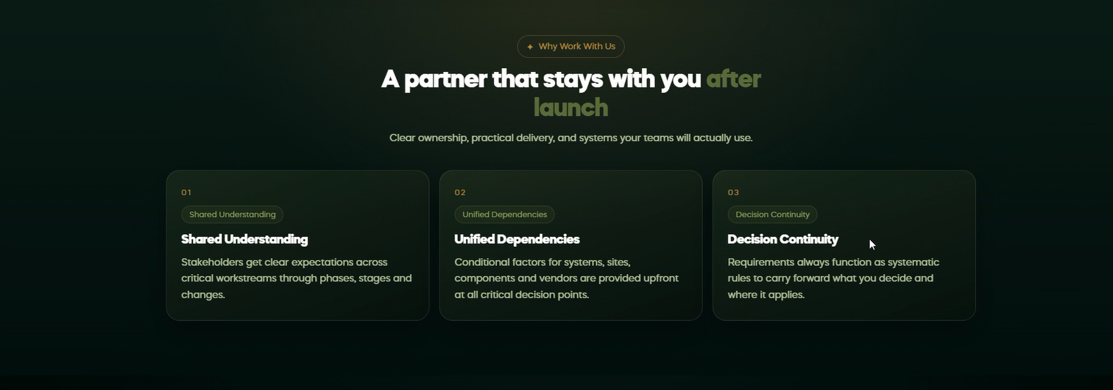
Card 1 content:
Badge: Construction First
Heading: Industry Before Technology
Paragraph: Before we recommend AI or software, we understand how your teams estimate, fabricate, inspect, and deliver projects.
Card 2:
Badge: Built Around Your Workflow
Heading: We Build What Fits
Paragraph: Every construction business is different. We design systems around your existing operations instead of forcing your team to adapt to generic software.
Card 3:
Badge: Engineering Partnership
Heading: Founder-Led Collaboration
Paragraph: You work directly with the people designing and building your solution. Faster decisions, clearer communication, and a shared focus on solving the right problems.
Card 4:
Badge: Long-Term Thinking
Heading: Built to Grow
Paragraph: Construction businesses grow. Every platform is designed to scale with new workflows, integrations, and future AI capabilities as your operations evolve.
Note:
- Use icons in cards.
- Increase card height so that content best fits in.
10- FAQ section (you’ve already made, keep it same)
11- Testimonials
Change the structure of testimonials section to this.
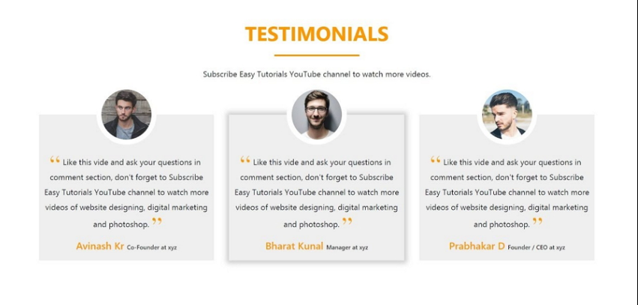
Note:
- Use white background for this whole section and make cards in dark green gradient color (like current color of cards) with white text, and Warm gold color for quotation marks and Client name.
- Also Move testimonials section before FAQ section.

11- Final CTA
Heading: Let's Talk About the Way Your Business Works.
Paragraph: Whether you're exploring automation, improving an existing workflow, or planning a new platform, we'll help you identify where technology can create the greatest operational impact.
CTA Button Primary: Book a Discovery Call
CTA Button Secondary: View Portfolio
12- Footer (keep same just change the color of main heading of footer to Warm Gold) Like Solutions, Company, Work, these headings should have warm gold colour rather than white.
- Also add social media icons, like email, LinkedIn, WhatsApp in footer.

Other changings:
1- Add a button below Featured Solutions section
Button: “View All Solutions”
2- Change navbar Contact button to “Book a Discovery Call”

